Table of Contents
ENVIRONMENT SETUP 1
BASE ENVIRONMENT CREATION 2
NEW DIRECTORY 2
INSTALL PYTHON 3
CREATE A VIRTUAL ENVIRONMENT 7
INSTALL PACKAGES 7
INSTALL NODEJS 10
CREATE ENV SCRIPT 12
INSTALL OLLAMA 14
Create Application Launcher Script 25
Steps to run the server/client 26

ENVIRONMENT SETUP
To do the hands on exercises and get one familiar with invoking an LLM in a programming environment, this environment setup – windows admin access is not necessary – section helps one setup base programming tools – Python & NodeJS

BASE ENVIRONMENT CREATION

NEW DIRECTORY
Open a Command Prompt
Win+R and then run cmd
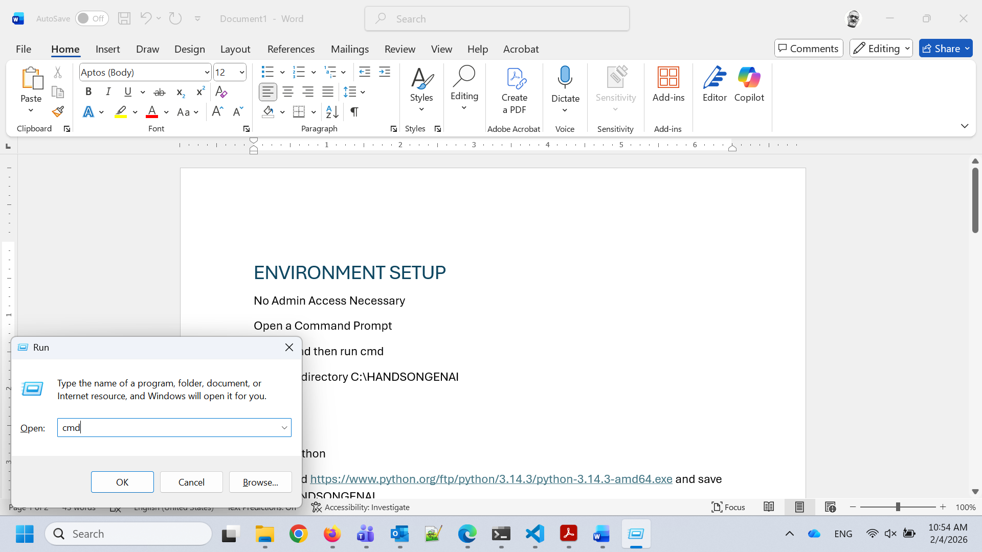
Create a directory C:\HANDSONGENAI
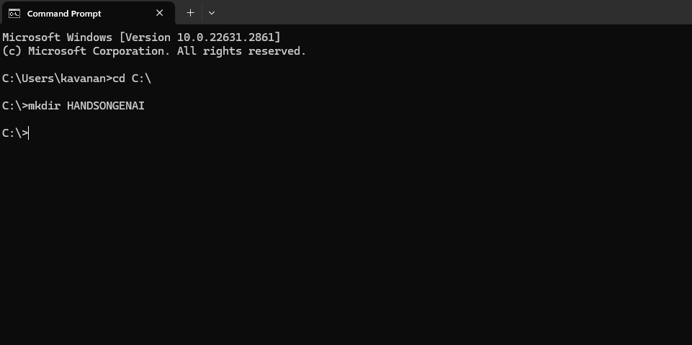

INSTALL PYTHON
Download https://www.python.org/ftp/python/3.13.11/python-3.13.11-amd64.exe and save to C:\HANDSONGENAI
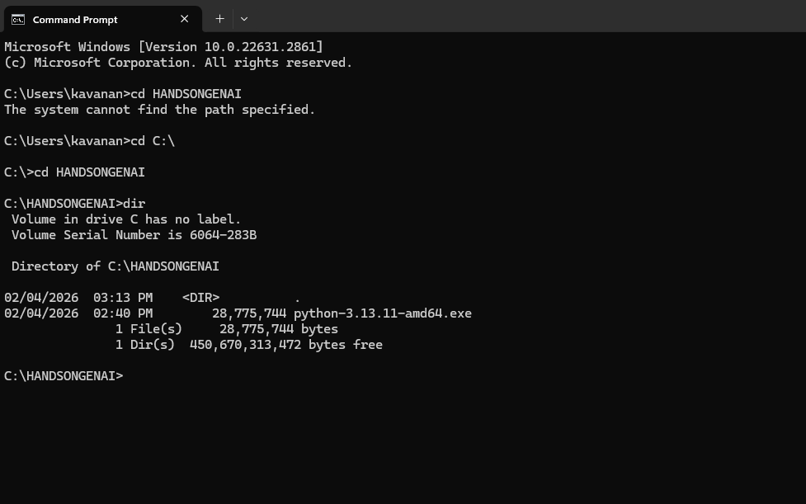
Run the downloaded executable to install Python to C:\HANDSONGENAI\py313. Unselect admin privileges and then in the next screen make the installation directory to be C:\HANDSONGENAI\py313
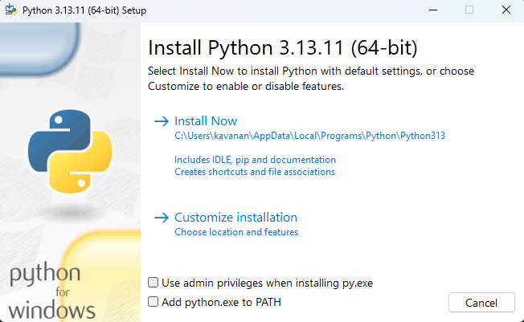

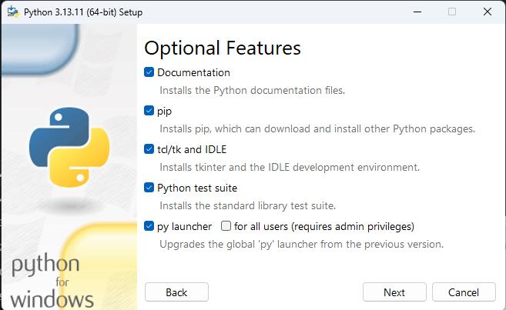
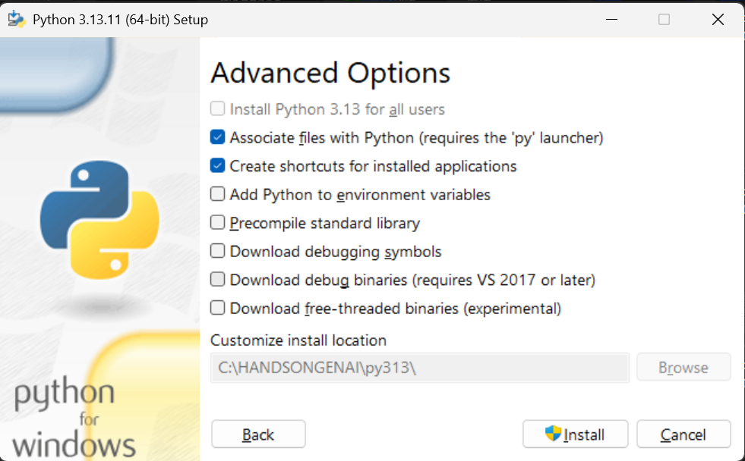
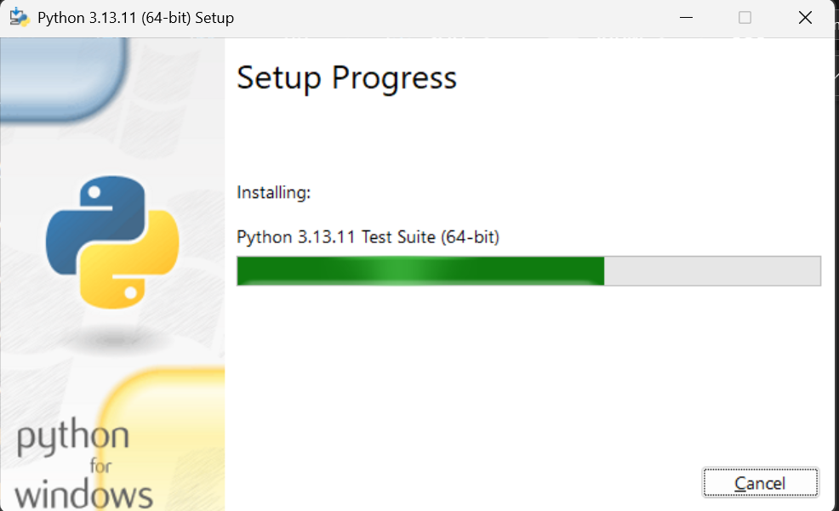
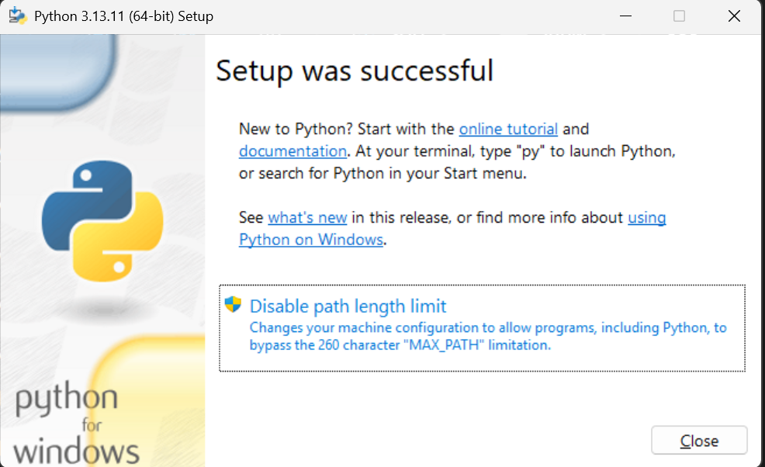
Verify python 3.13 is installed as below
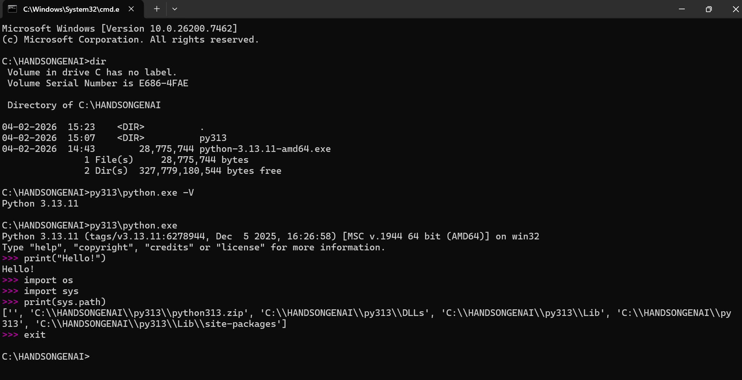

CREATE A VIRTUAL ENVIRONMENT
Execute the commands as below (py313\python -m venv vpy313) to create the virtual environment and activate (vpy313\scripts\activate) the virtual environment. Verify python in the virtual environment works
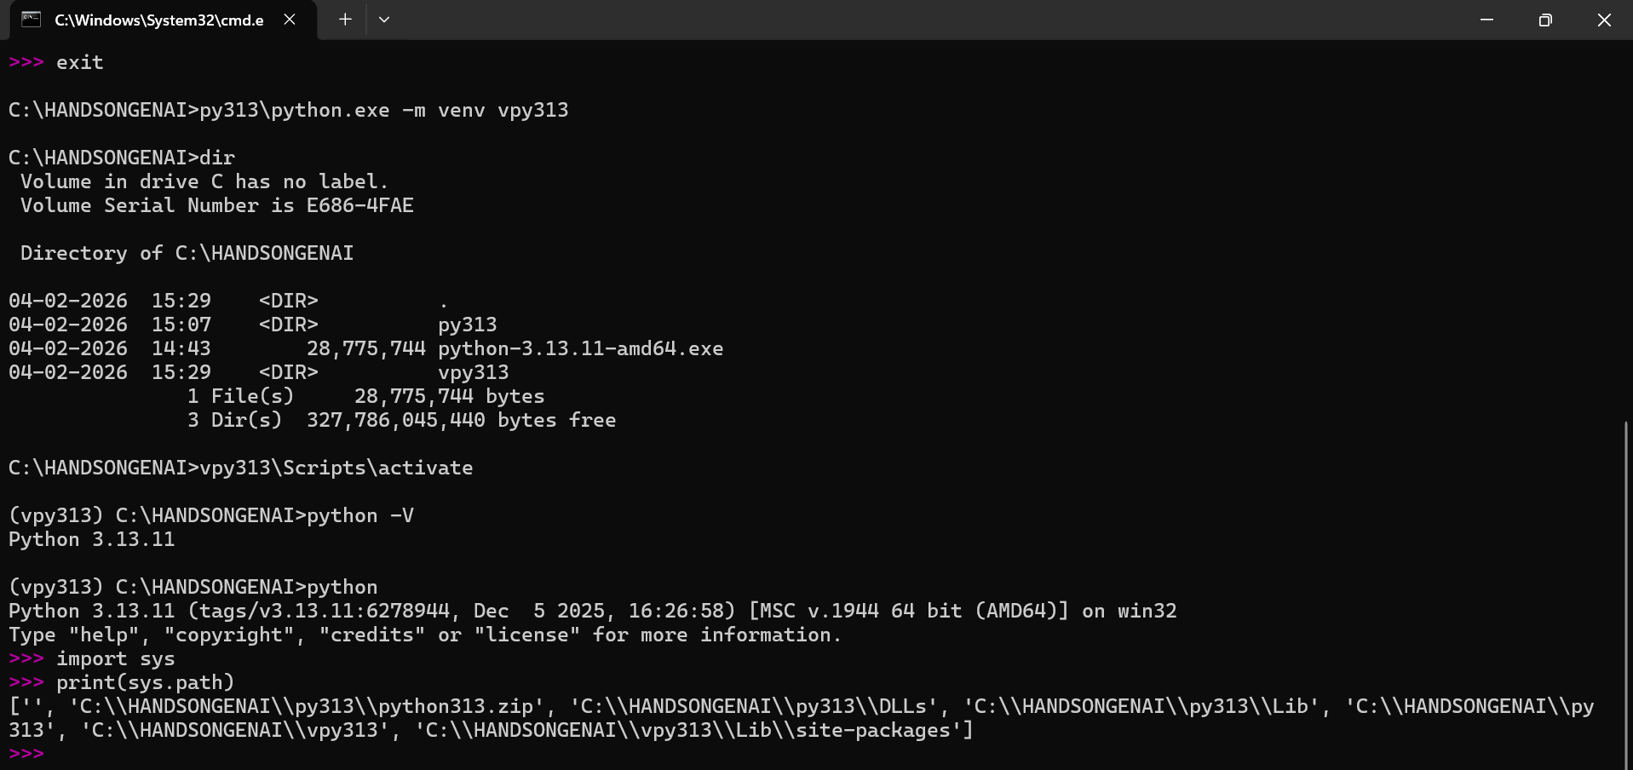

INSTALL PACKAGES
Create a requirements.txt file in C:\HANDSONGENAI directory. The contents are as below
# Core Frameworks (Stable 1.0+ Releases)
langchain>=1.2.0
langgraph>=1.0.0
langchain-core>=1.2.0
# LLM Partner Packages (Compatible with v1.0 standard)
langchain-google-genai>=4.2.0 # For Gemini 3 and adaptive thinking models
langchain-openai>=1.1.0 # For OpenAI (GPT-5/o1 series support)
langchain-ollama>=0.2.0 # For local Ollama models with native tool-calling
# Supporting Utilities
langchain-community>=0.3.0
python-dotenv>=1.0.1 # For environment variable management

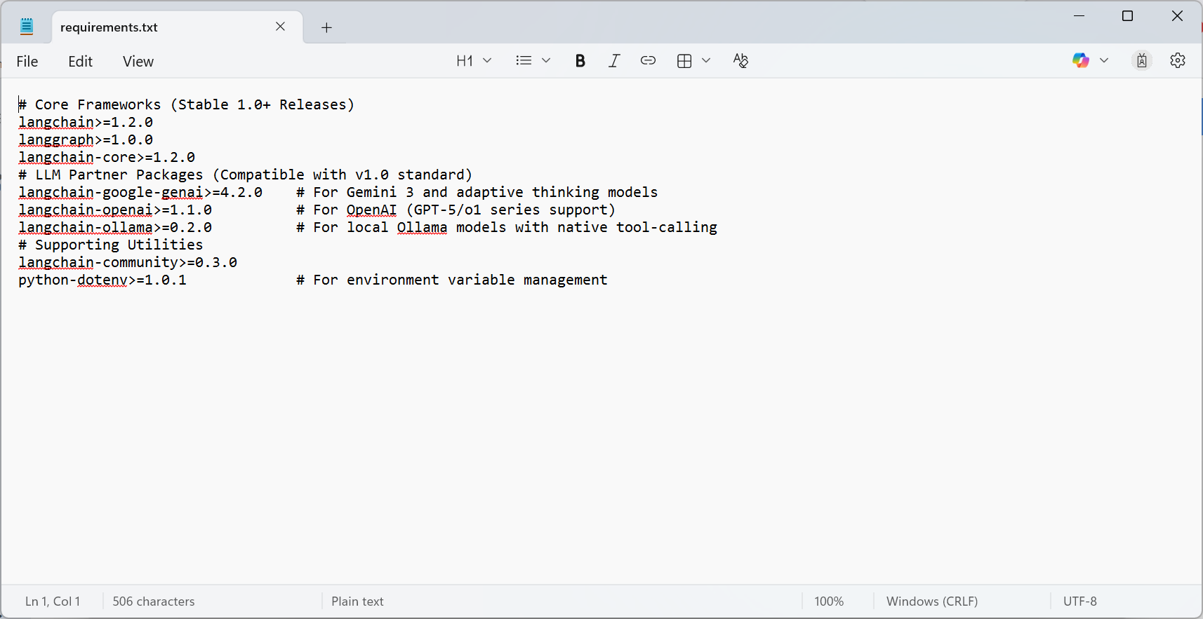

Run this pip command to install the packages
pip install -r requirements.txt --disable-pip-version-check
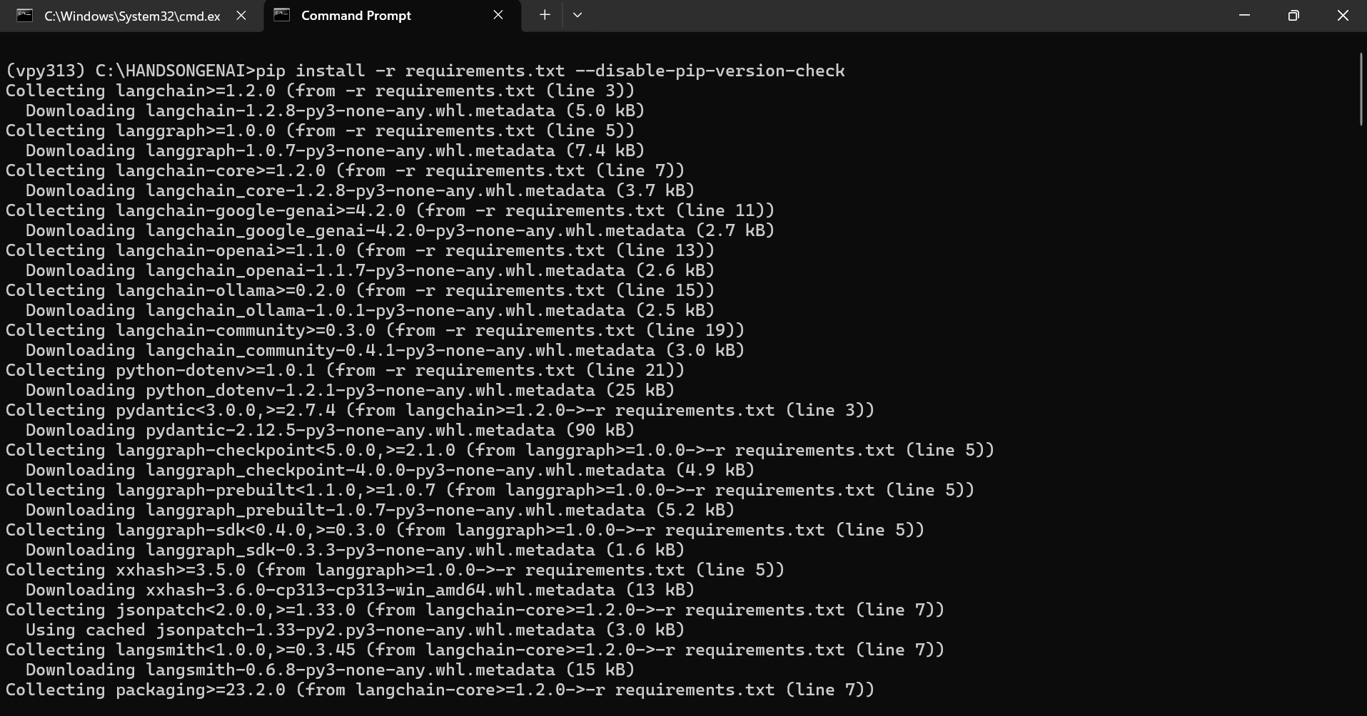
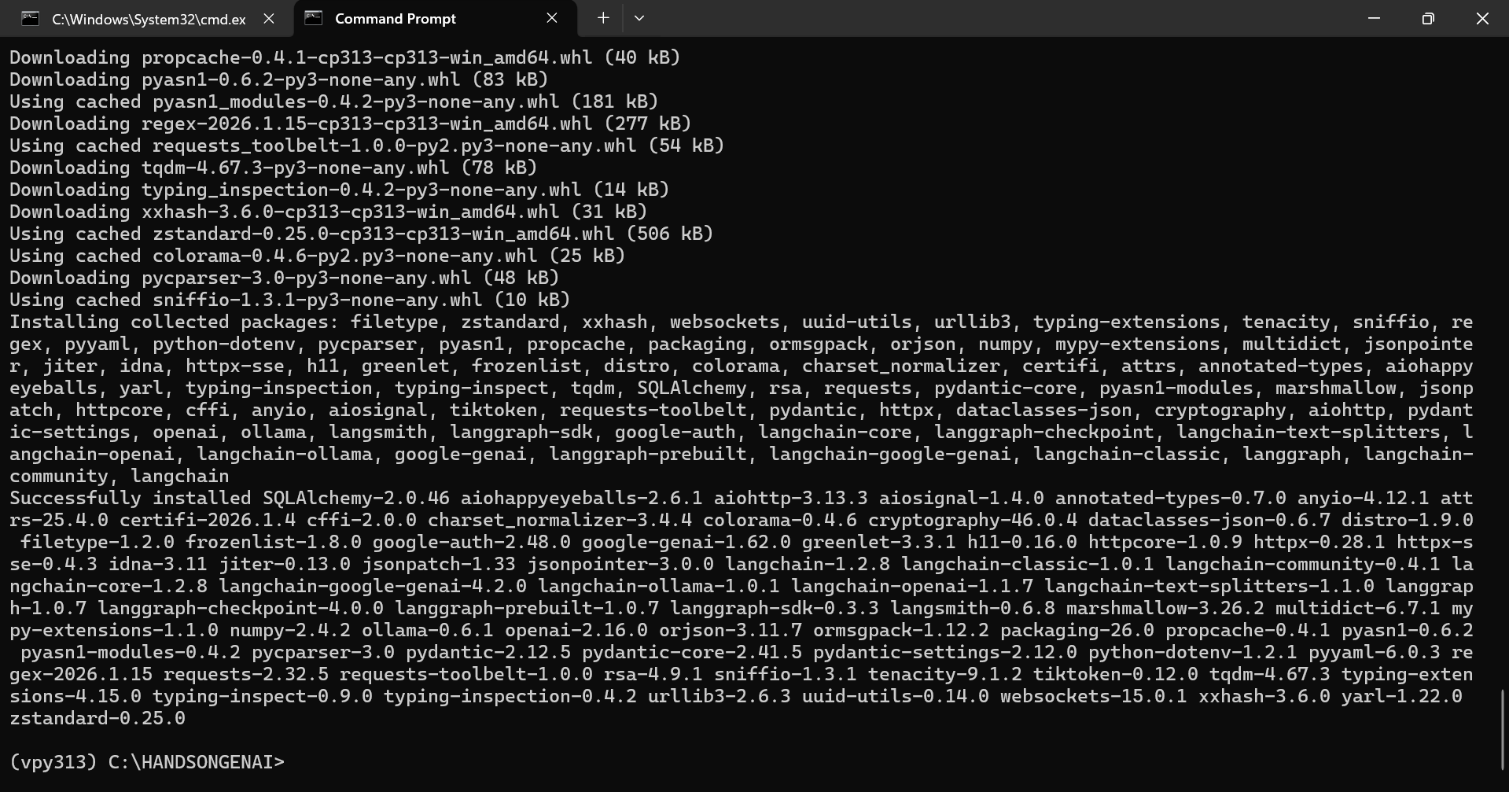

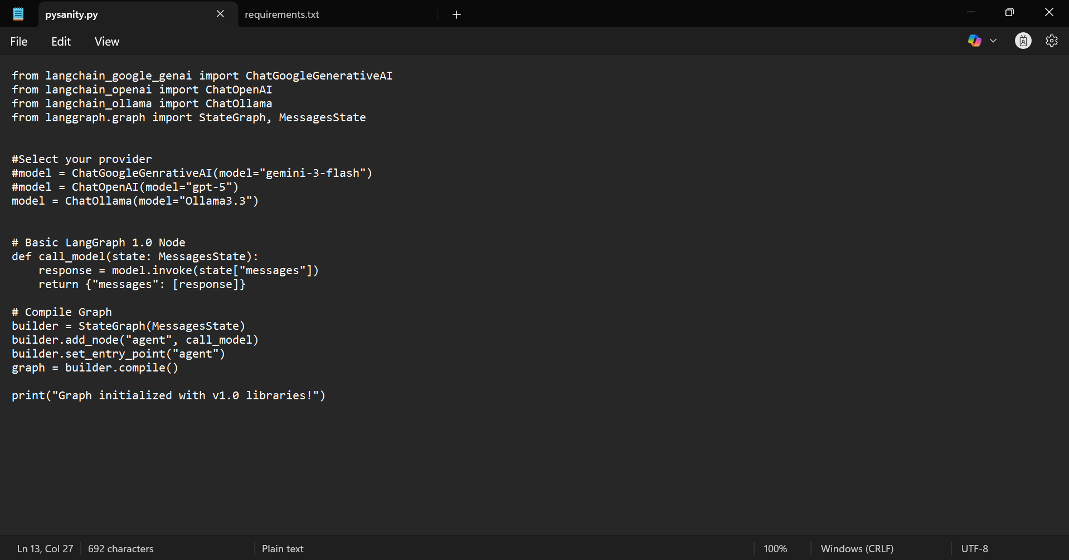
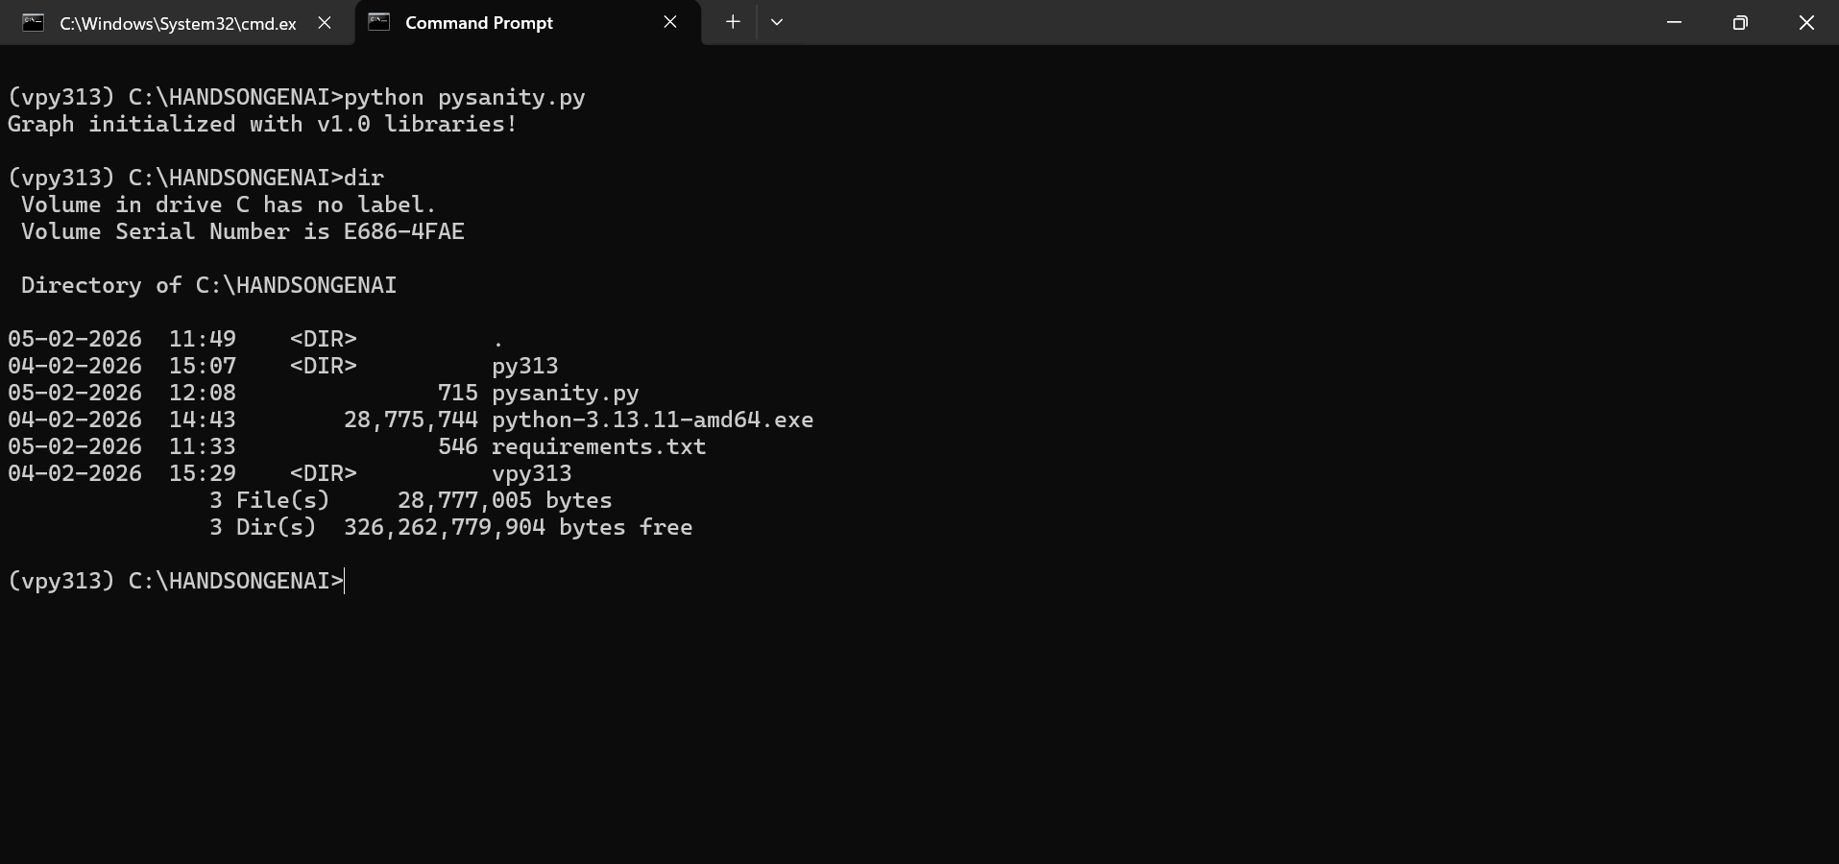

INSTALL NODEJS
Download https://nodejs.org/dist/v24.13.0/node-v24.13.0-win-x64.zip and save to C:\HANDSONGENAI. Unzip the contents of the downloaded zip to C:\HANDSONGENAI\nodejs. Now, nodejs software will be available as below

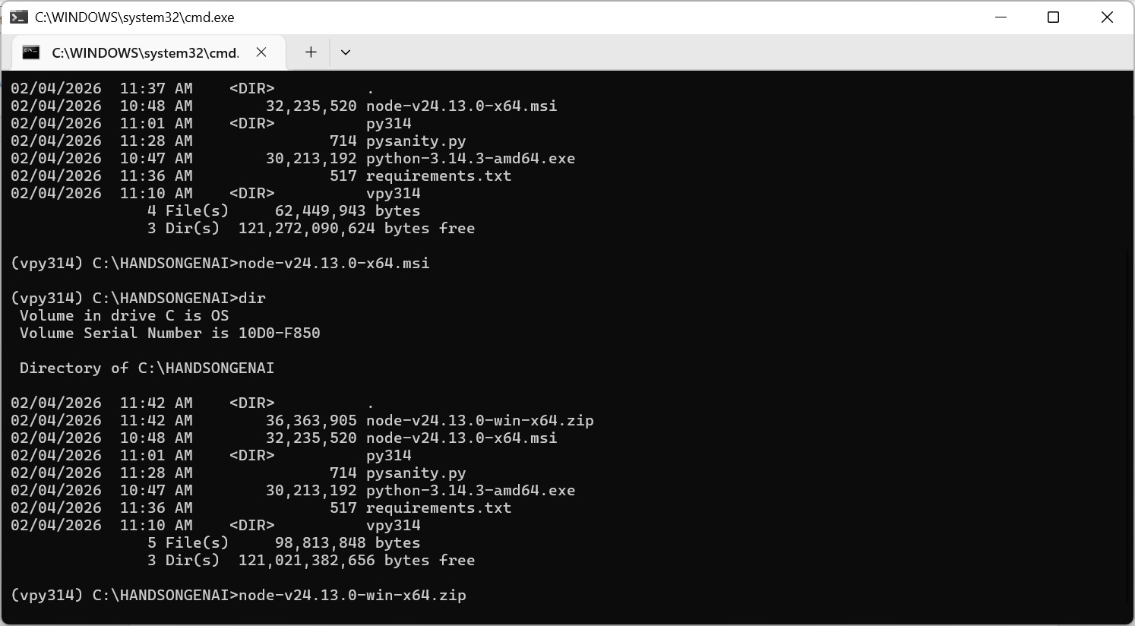
I suggest to rename the folder name to v24 to keep it short and verify npm works.
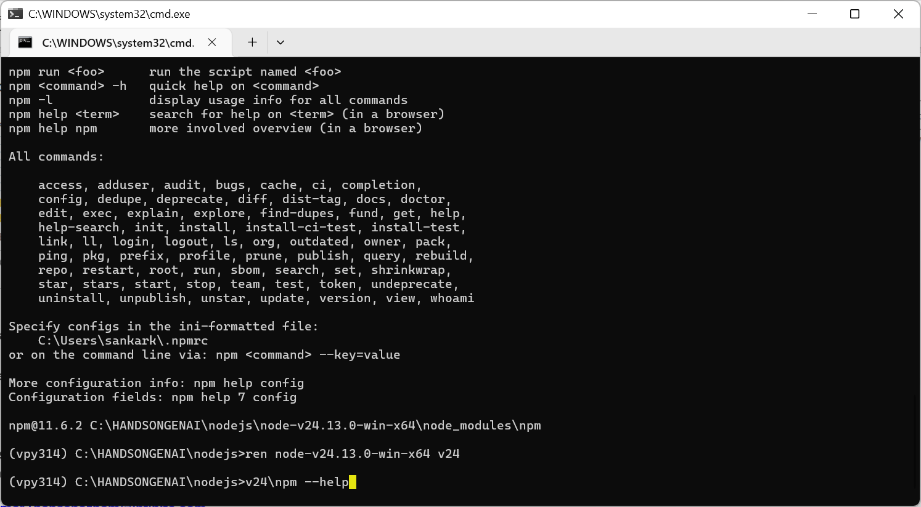
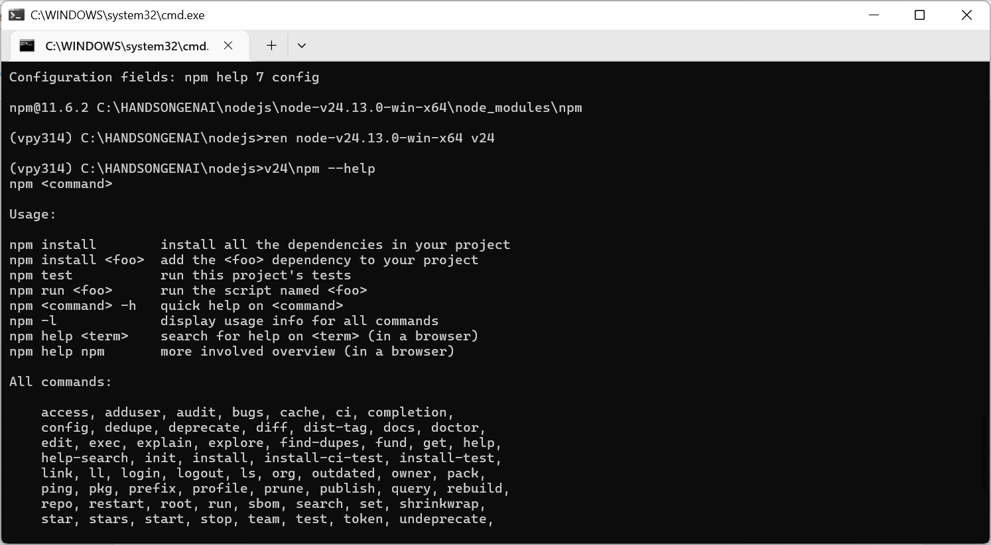

CREATE ENV SCRIPT
Create a SETENV.cmd in C:\HANDSONGENAI and paste the following lines of code in it:
@echo OFF
SET GENAIHOME=C:\HANDSONGENAI
SET NODEJS_HOME=%GENAIHOME%\nodejs\v24
SET PATH=%NODEJS_HOME%;%PATH%
if not exist vpy314 (
echo Creating virtual environment...
python -m venv vpy314
)
echo Activating Virtual Environment and calling Application to Launch.....
cmd /k "vpy314\Scripts\activate && APP.cmd"
pause

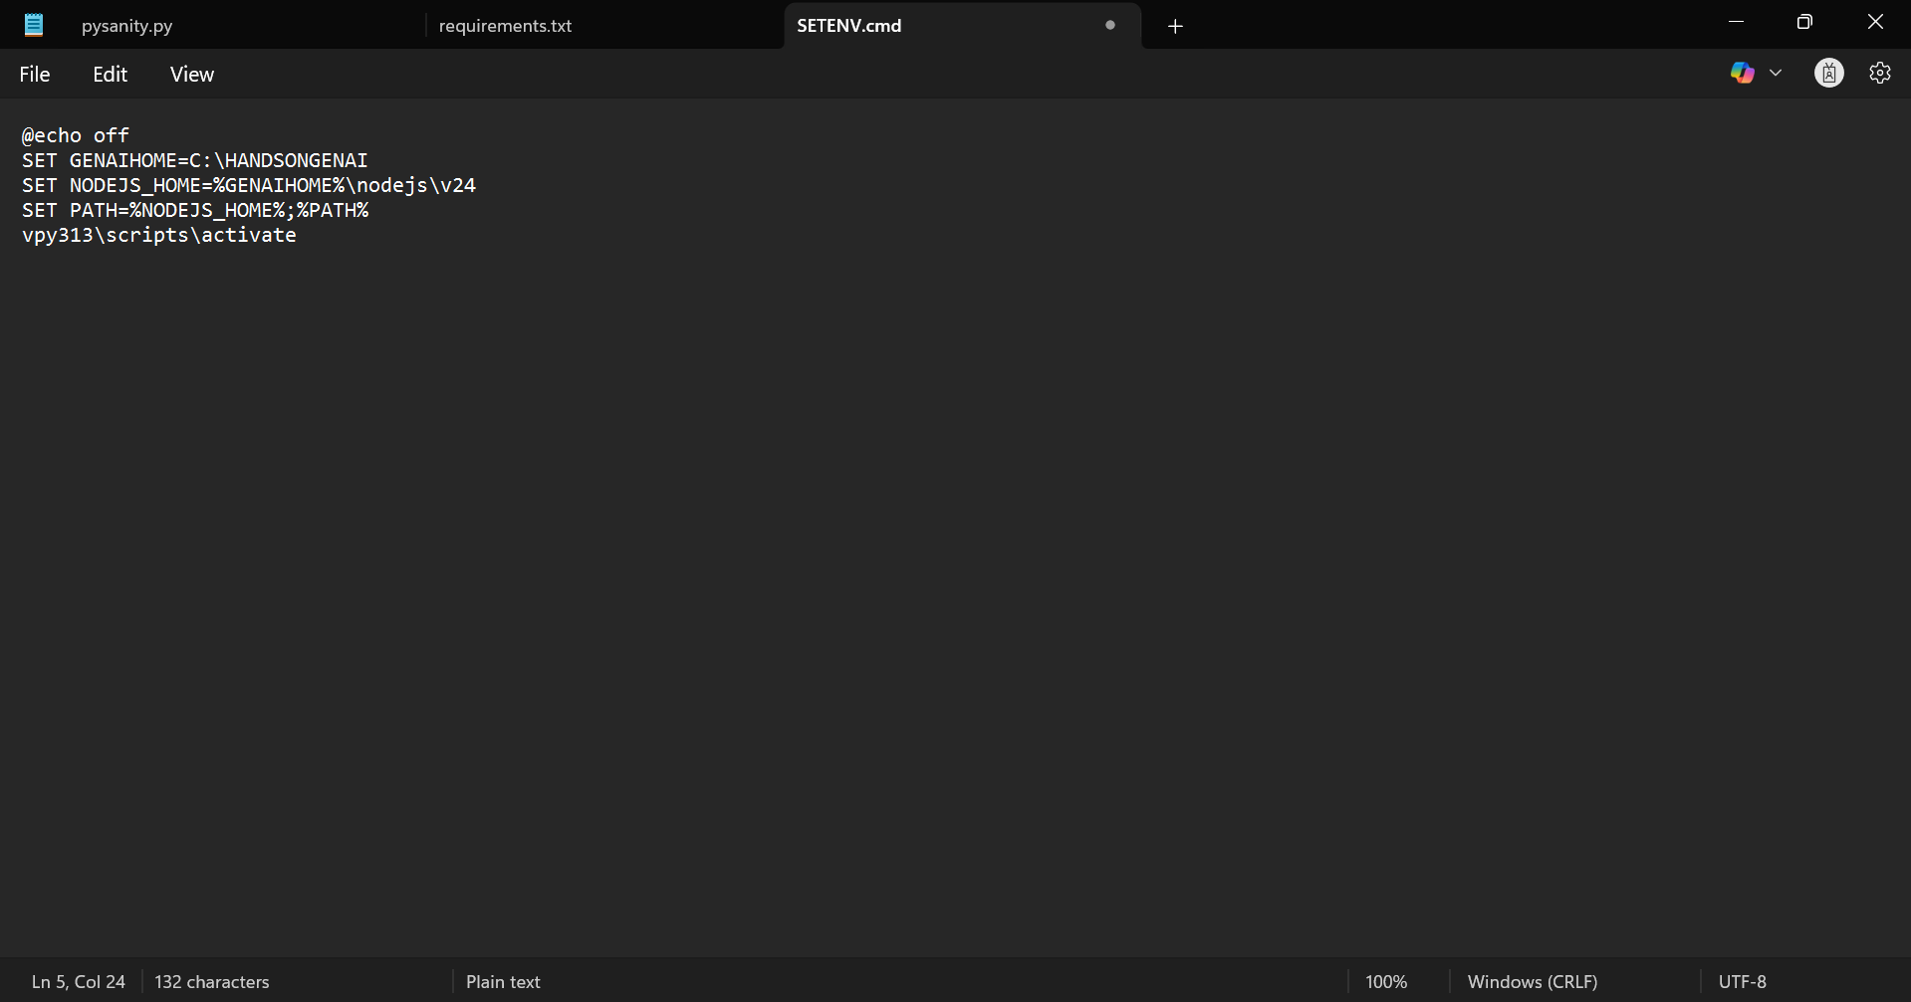
Quit the command prompt. Open a command prompt again and then change directory to C:\HANDSONGENAI and execute SETENV.cmd and verify that python and npm are available

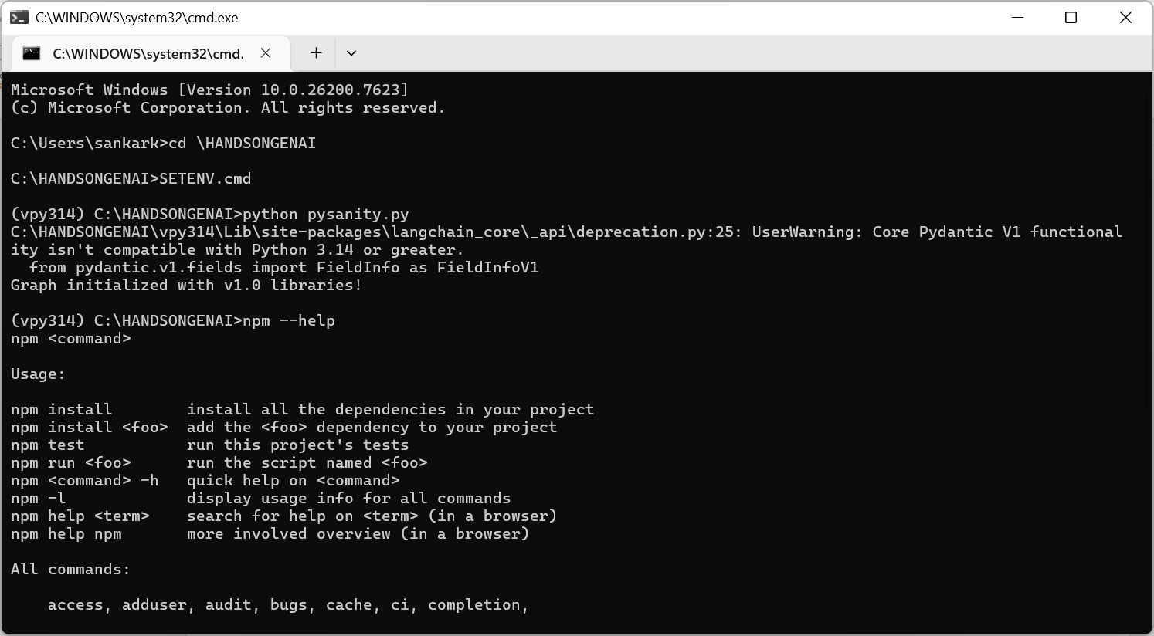

INSTALL OLLAMA
Download https://ollama.com/download/OllamaSetup.exe to C:\HANDSONGENAI
Then execute the downloaded file
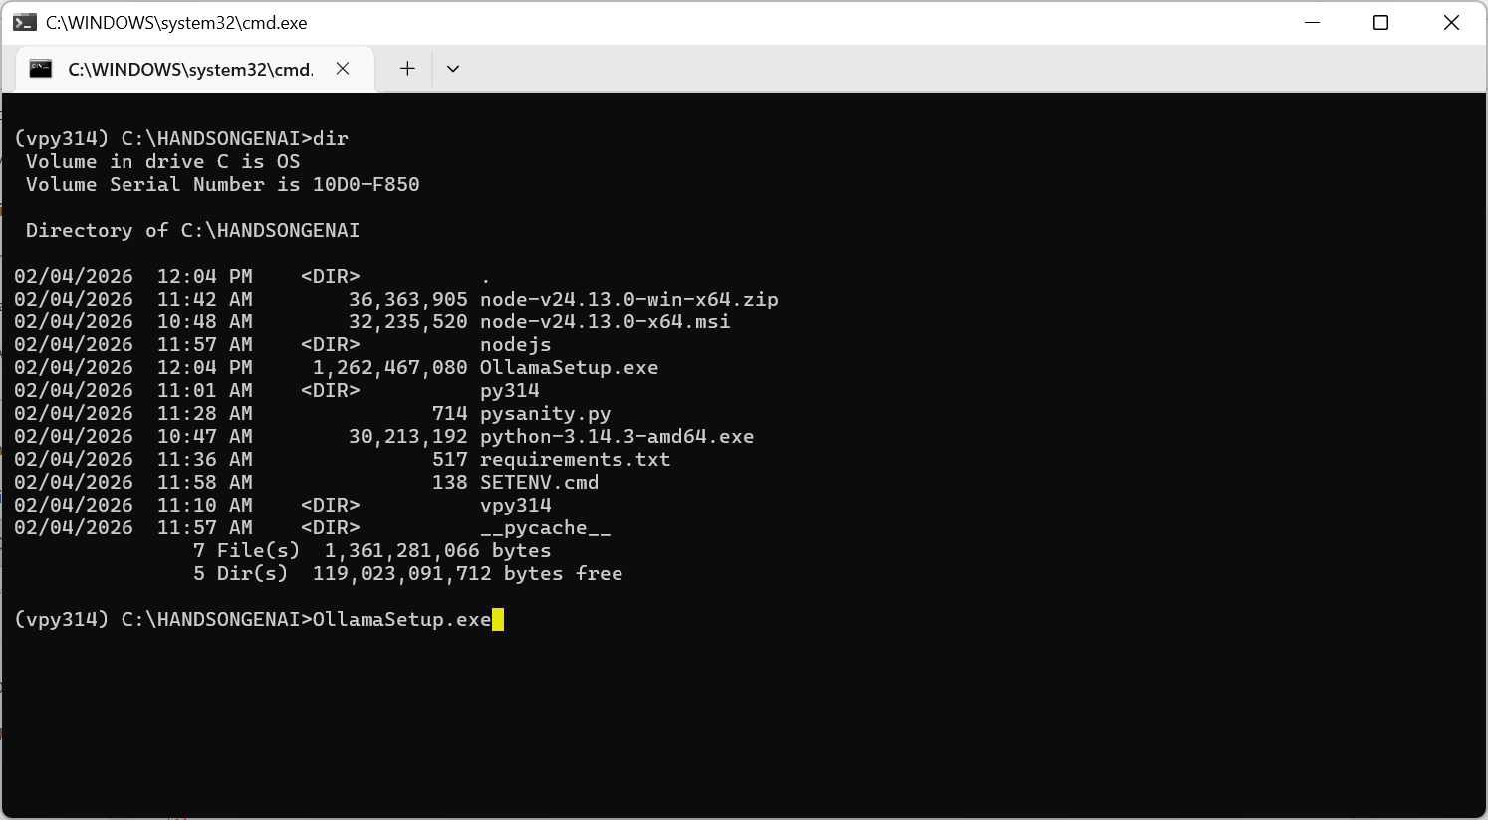
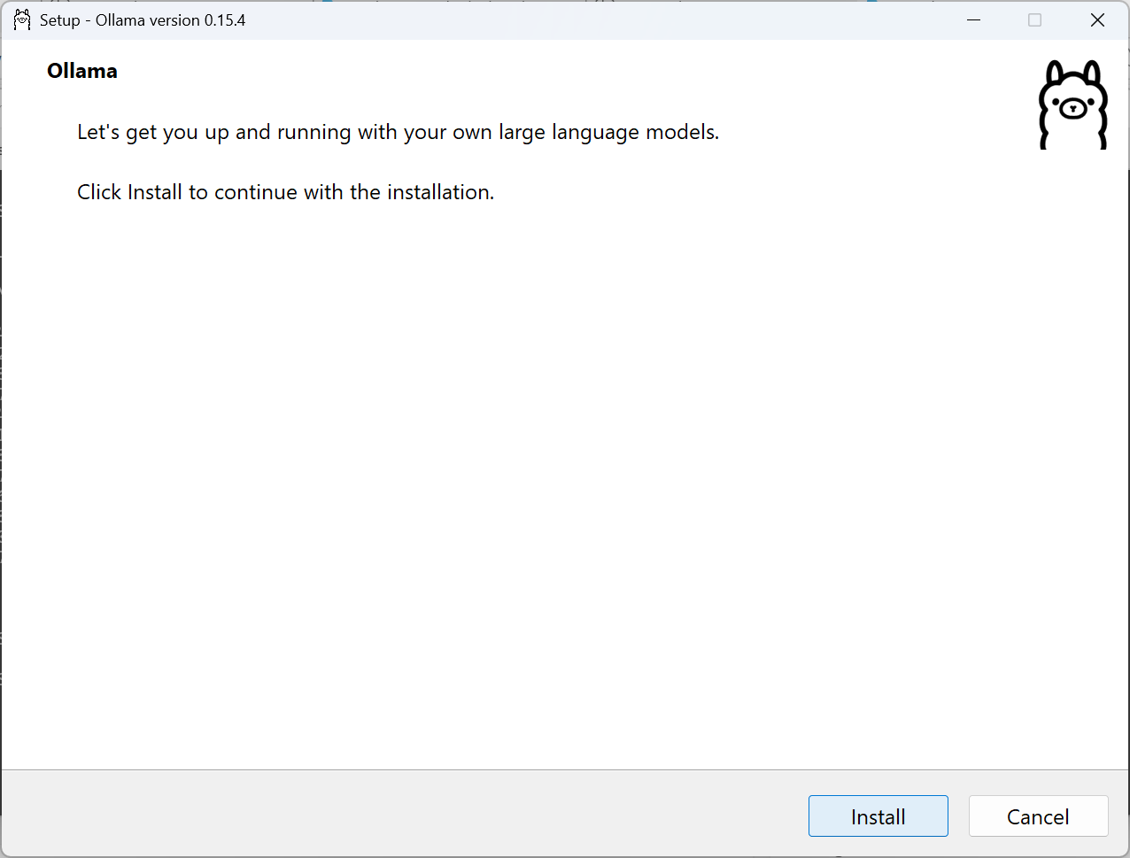
It will automatically install to the logged in users AppData\Local. Let it be so
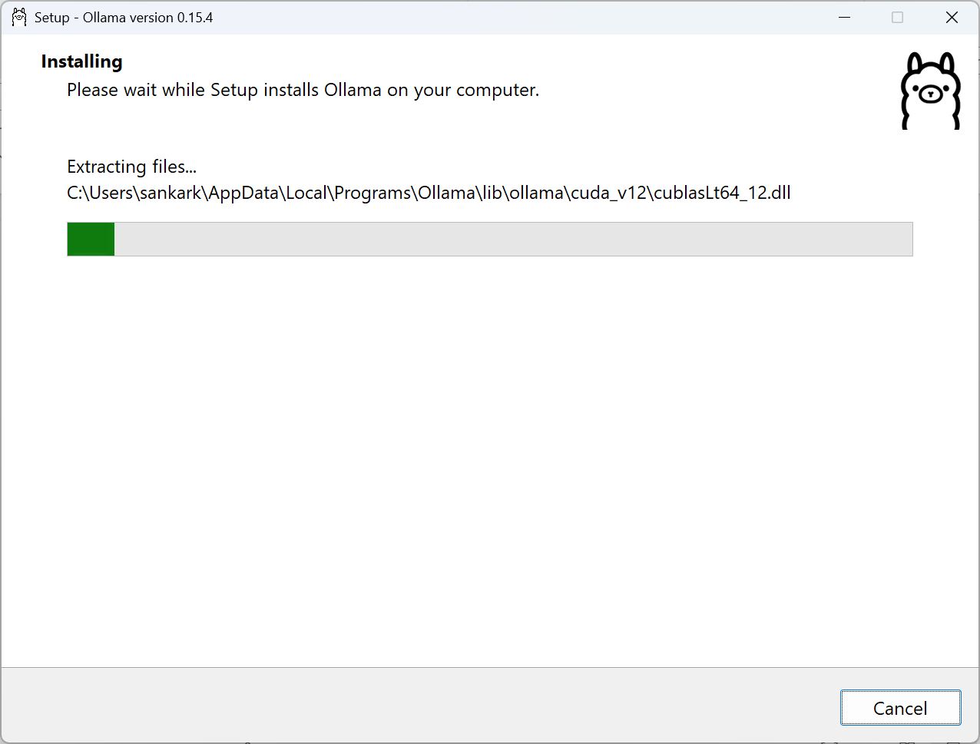
After installation, Ollama will automatically open up
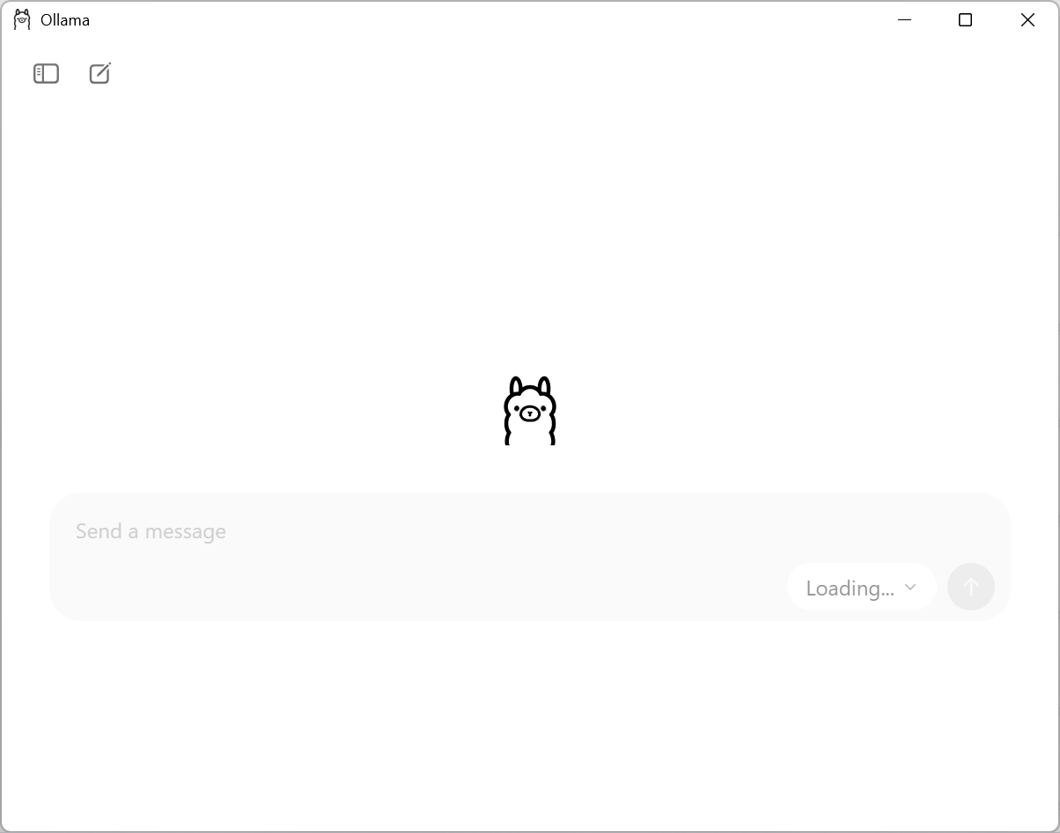
If the UI seems unresponsive or stays “Loading..” quit and open after sometime. After that, select gemma3:4b as a model and ask it any question (example below). This should download the model – it will take some time depending on the network – and then result in an answer.
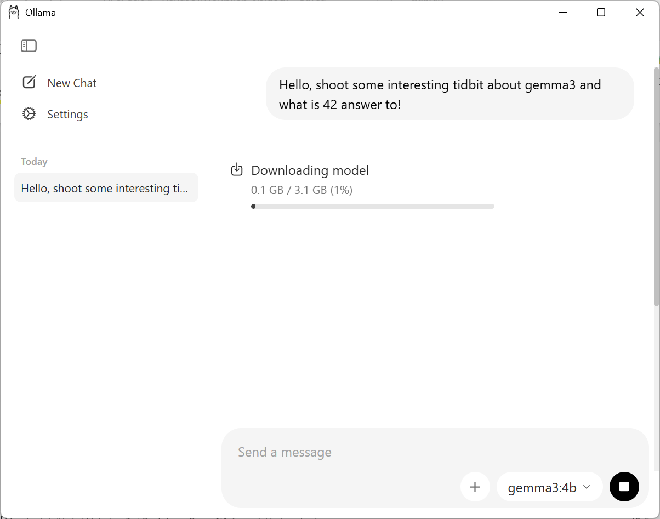
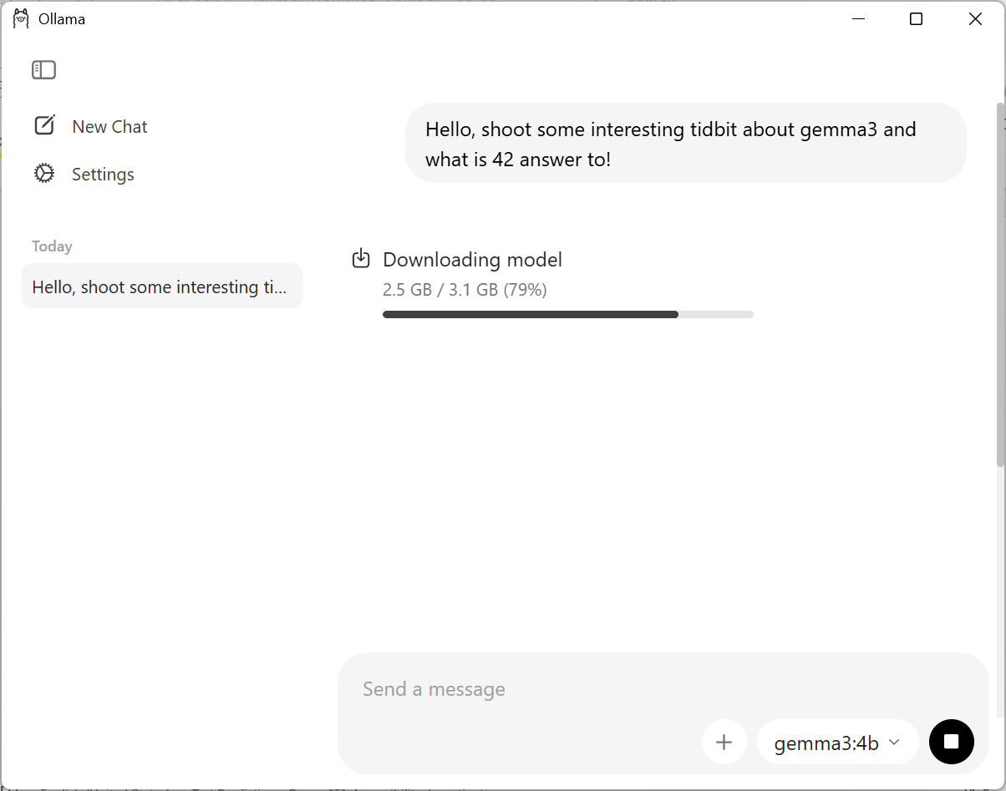
After downloading the model, it shall present the answer as below
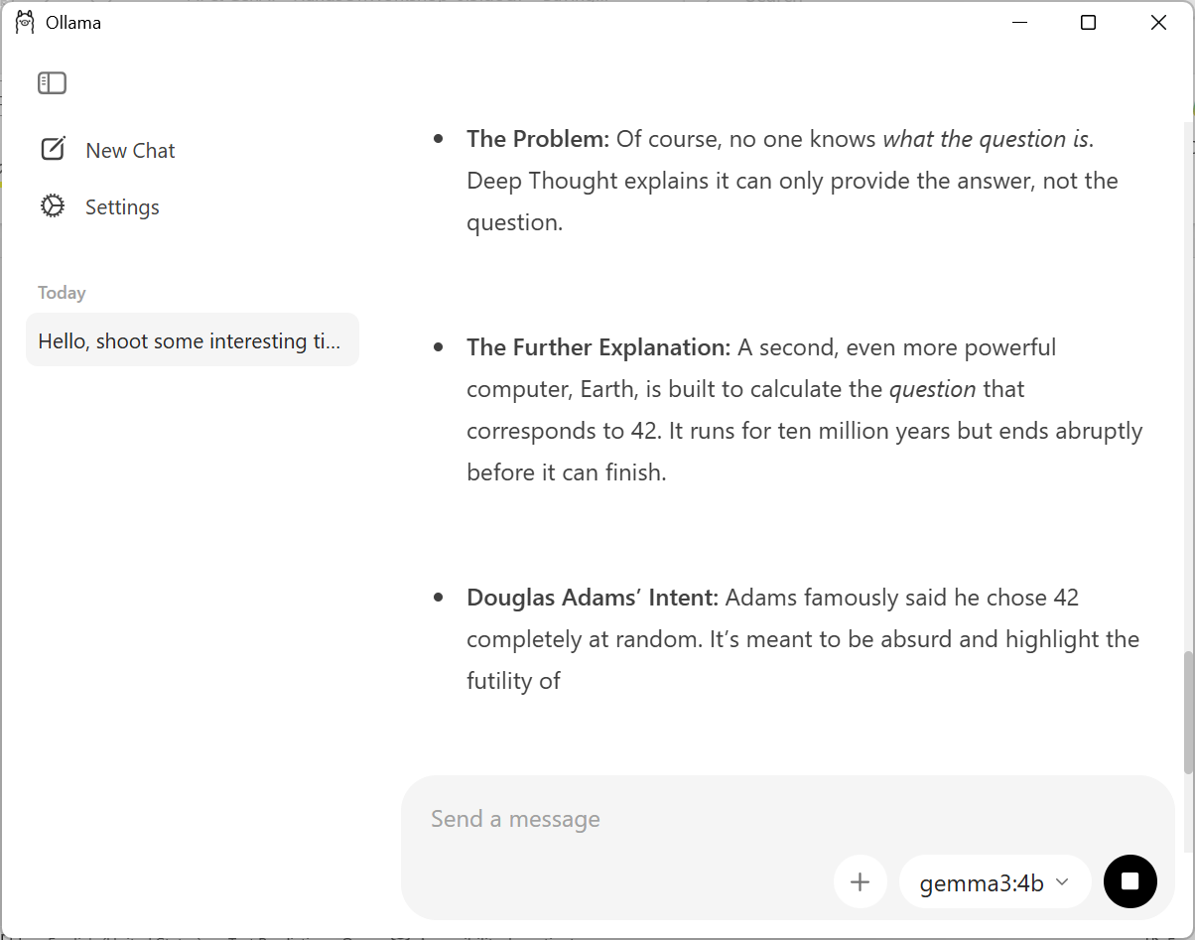
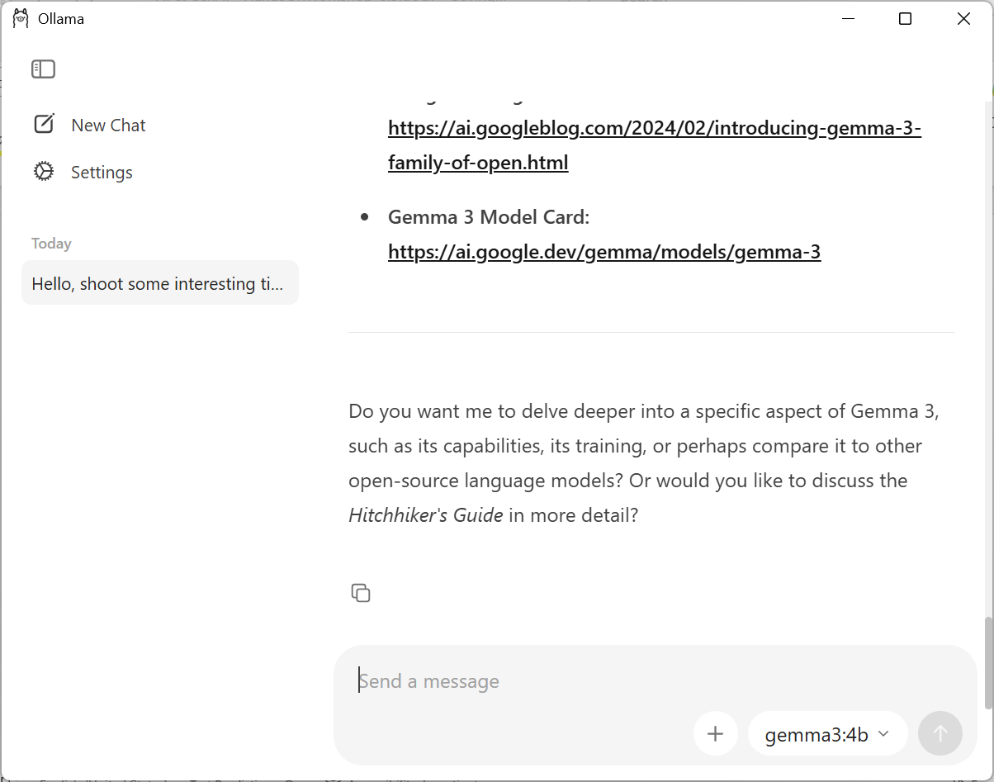
You can also try with gemma3:1b which is a lower sized model. As the model sizes increase, one would need machines with GPU/VRAM or atleast 2-3x RAM of the model size. So if one downloads a 12b model, better to have atleast 24G+ RAM.
If all works and you see an answer that means the environment for playing around with programming in python or nodejs + local LLM (not very powerful) is ready.

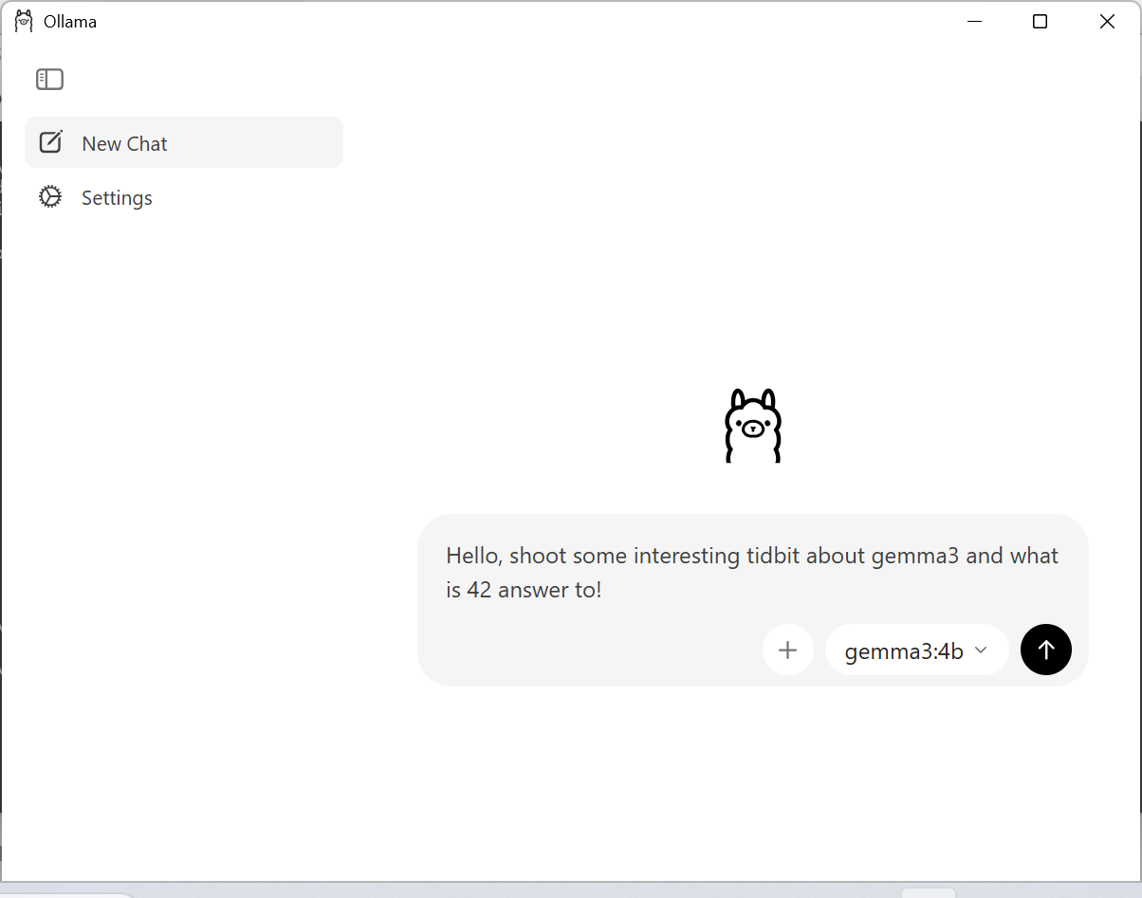

To test ollama being accessible via HTTP api create a simple test program and run it.

import requests
import sys

def chat():
# 1. Usage check
if len(sys.argv) < 2:
print(f"Usage: python {sys.argv[0]} \"your prompt here\"")
sys.exit(1)

# 2. Configuration - Note the exact model name
url = "http://localhost:11434/api/generate"
model_name = "gemma3:4b"
prompt = sys.argv[1]

payload = {
"model": model_name,
"prompt": prompt,
"stream": False
}

try:
# 3. Sending the request
response = requests.post(url, json=payload, timeout=300)

# If this raises a 404, check if 'gemma3:4b' is actually pulled
response.raise_for_status()

result = response.json()
print(result.get("response", "Error: No response text returned."))

except requests.exceptions.HTTPError as e:
if e.response.status_code == 404:
print(f"Error 404: Endpoint not found or model '{model_name}' not pulled.")
print("Try running: ollama pull gemma3:4b")
else:
print(f"HTTP Error: {e}")
except Exception as e:
print(f"An unexpected error occurred: {e}")

if __name__ == "__main__":
chat()
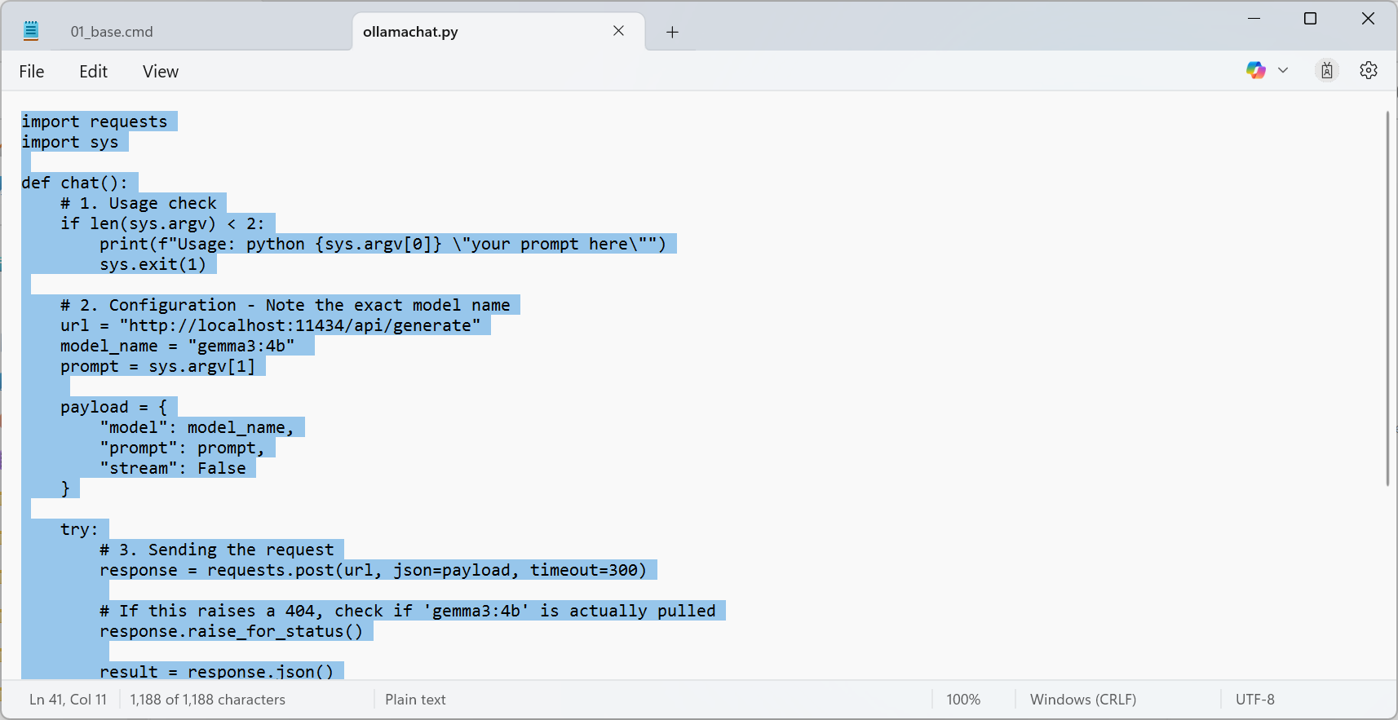

Like below.
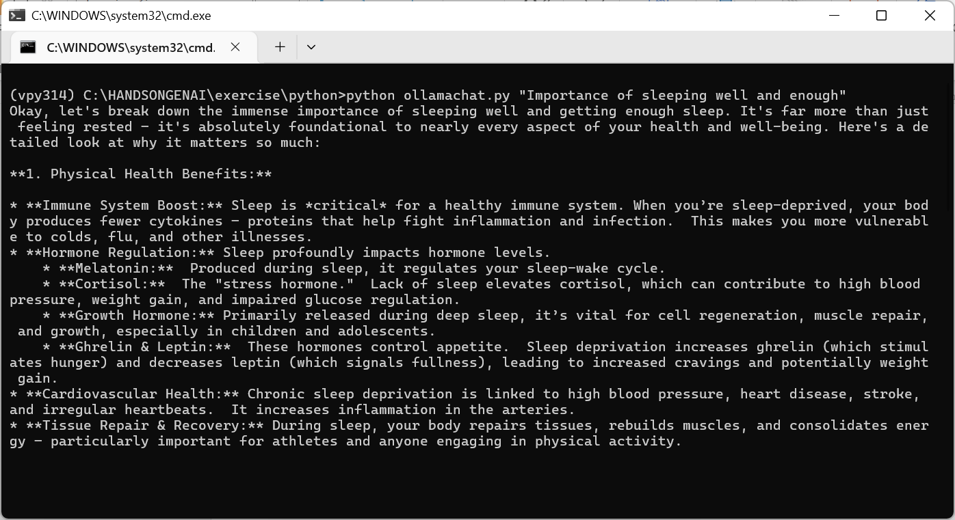

Now one has setup basic environment that can be used to learn how to consume LLMs using python and nodejs using a locally hosted ollama.
Next step would be to learn how to use a hyperscaler LLM like Gemini or OpenAI or Claude etc.

Create Application Launcher Script
Create a APP.cmd in C:\HANDSONGENAI and paste the following lines of code in it:
@echo off
SET GENAIHOME=C:\HANDSONGENAI
SET NODEJS_HOME=%GENAIHOME%\nodejs\v24
SET PATH=%NODEJS_HOME%;%PATH%

:: 1. Bypass SSL issues
call npm config set strict-ssl false

:: 2. THE FIX: Force NPM to ignore dependency conflicts globally for this session
SET NPM_CONFIG_LEGACY_PEER_DEPS=true

echo -------Step 1-------
pushd "%GENAIHOME%\nodejs24"
call 01_base.cmd

echo -------Step 2-------
echo Initializing Client in background...
start "Vite-Client" cmd /c "02_client.cmd"

timeout /t 5

echo -------Step 3-------
echo Launching All Services via 03_run...
:: Now when 03_run calls 'npm install', it will use legacy-peer-deps automatically
call 03_run.cmd

popd
Pause

Steps to run the server/client
Follow the steps below to run the server/client. Make sure you have finished all the required setup mentioned above.
- Double-click on `SETENV.cmd` (or) type the command as follows while on path C:\HANDSONGENAI

SETENV.cmd

This will launch the SETENV.cmd script we wrote.

- The environment will set-up and calls APP.cmd after setting the environment. This will popup new CMD windows in parallel to run the server & client.
- On first run, you are expected to confirm for installing vite packages on the CMD Window. Type ‘Y’ and hit enter.
- Now click on `Ignore files and continue`. Use your arrow keys to navigate and Enter to choose an option.
- Select the options as shown in the above image & dependencies will be soon installed with npm.
Server Window:

Client Window:
Now, the application is ready to use. Open a browser of choice and visit http://localhost:5173/

